How To Set Up The Project

If you’re like me and don’t want to move the libraries under C:\ and would rather have them where you want them, then this is the guide for you!

Now that I’ve got the obvious and cliché stuff out of the way. Let’s begin.

First, you want to clone the project onto your computer. This should be simple enough using the GitHub client, so I’m going to assume you can get yourself through this part.

You should now have the project. Let’s take a look at it.

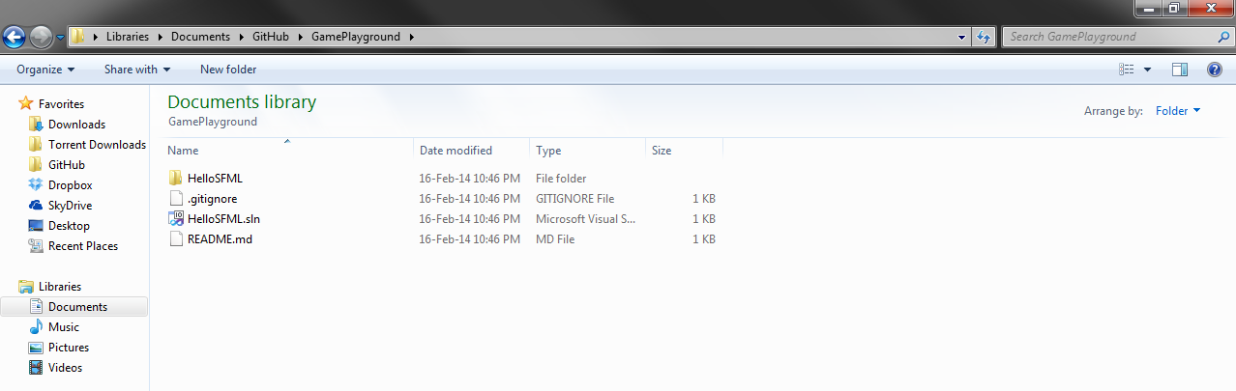

Ain’t that a beauty?

I apologize, back to work. I’m going to assume you’ve already compiled and built Box2D v2.2.1 and downloaded SFML 2.1 for Windows 32 bit and VC++ 2010. Place the folders where you want them to be on your computer. For me, it was in My Documents under Visual Studio 2013.

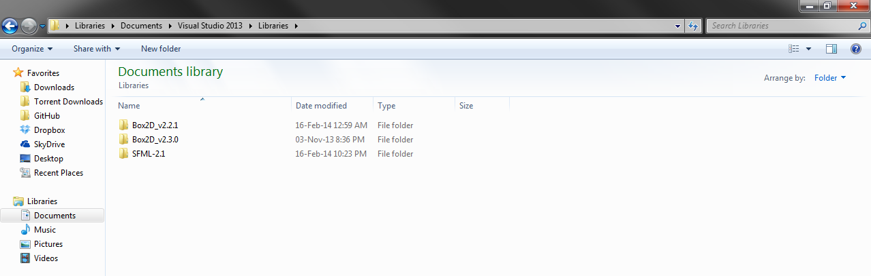

So, now open the project in Visual Studio. I’m going to use Visual Studio 2013. You may use the same, 2010 or 2012, as long as you compile the code as is and don’t upgrade it for your current version.

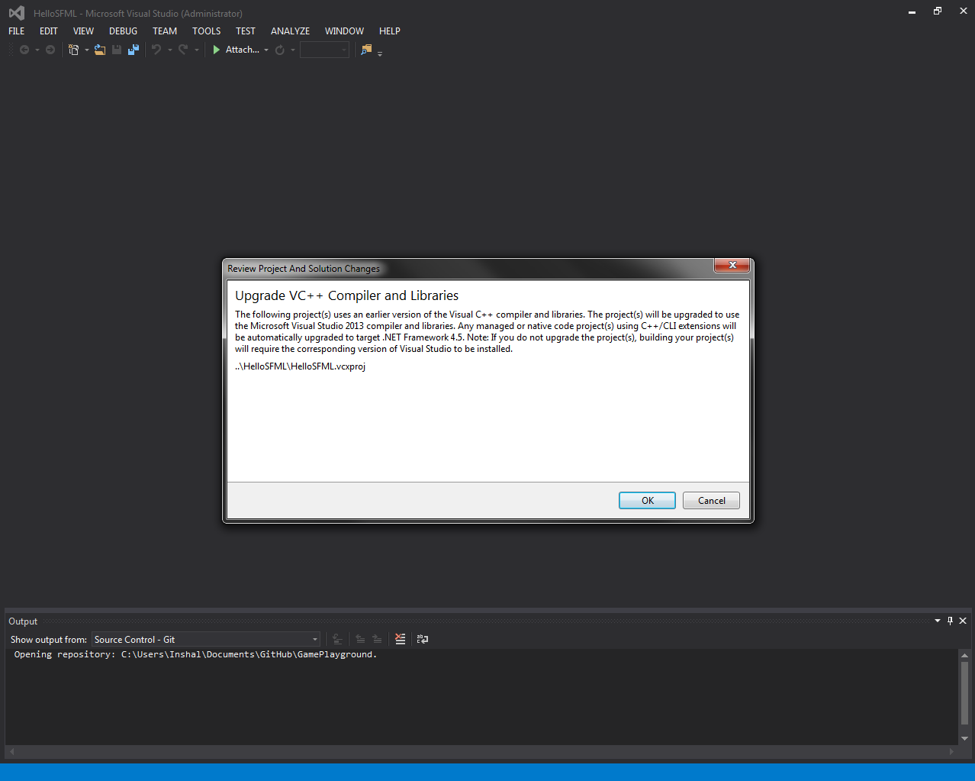Select Cancel, as you upgrading your project will cause problems for those using older IDE’s.

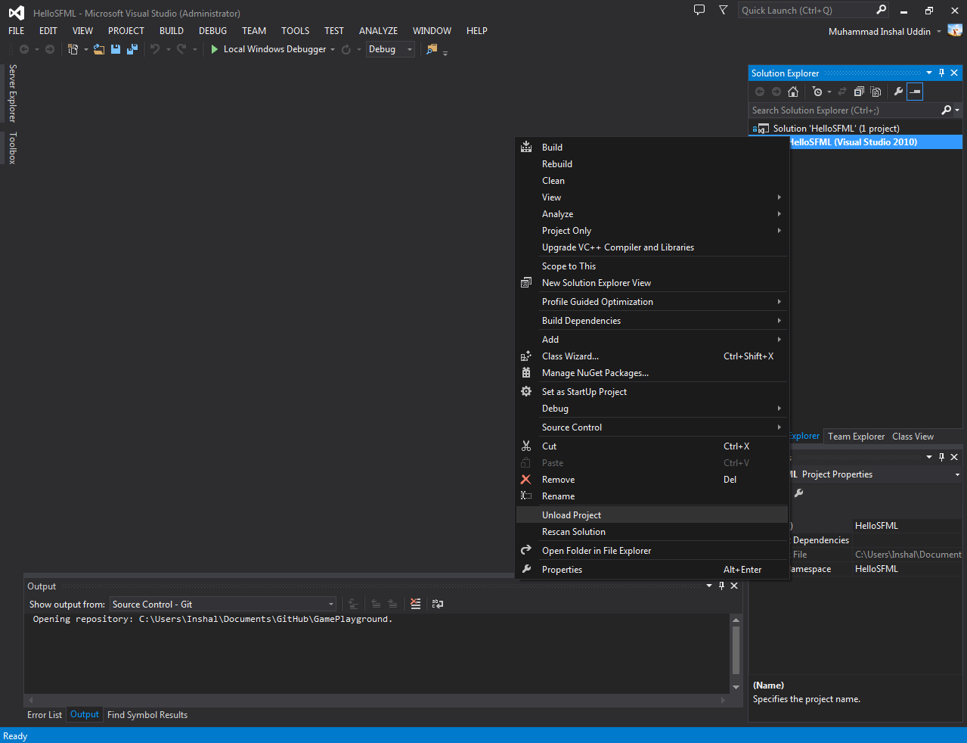Right click the solution and select “Unload” near the bottom.

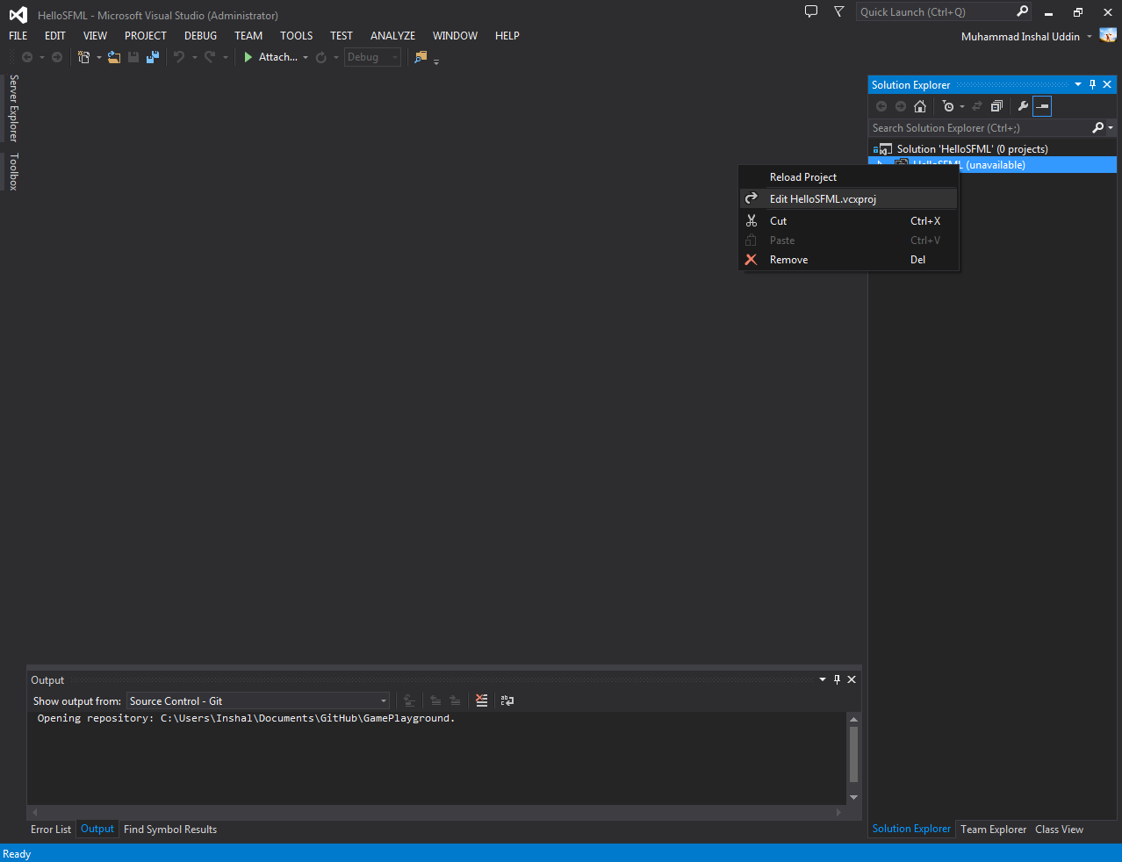Now, right click the solution again and click “Edit HelloSFML.vcxproj”.

This will open an XML file in the main window. Don’t be intimidated by it. Just keep reading the instructions and believe. And keep your hands in your pockets! And don’t touch anything. I’m serious. You could unravel the very fabric of space and time by altering a single variable here.

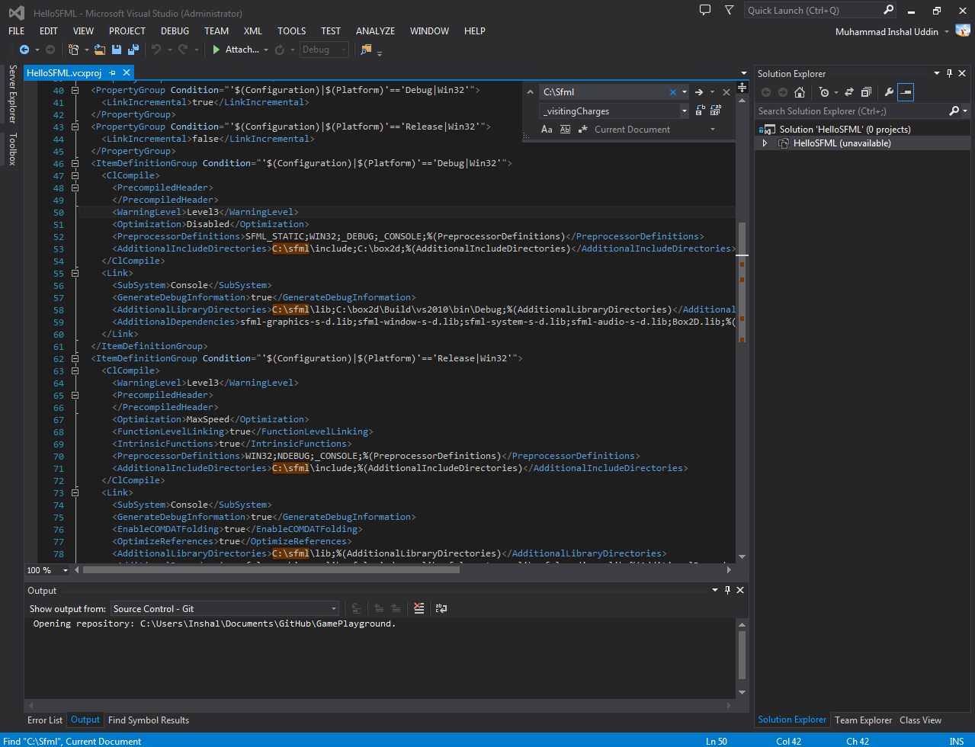Jokes aside, click somewhere in the file and press Ctrl + H. This should bring up a replacmet box in the top-right corner. Type “C:\SFML” in the first field.

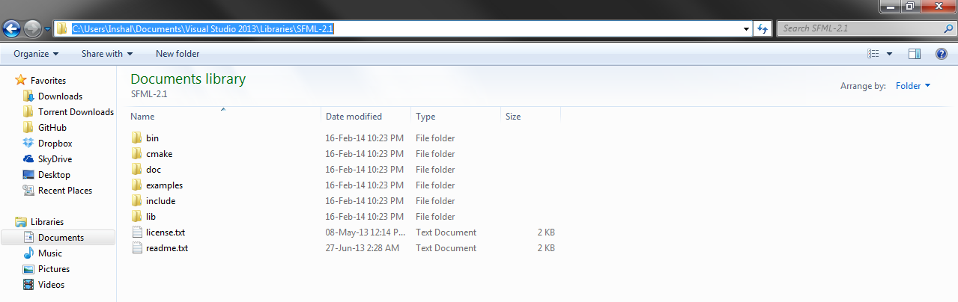Cool, huh? Now we just need to “replace” the highlighted bits with where the library actually is. For me it’s here:

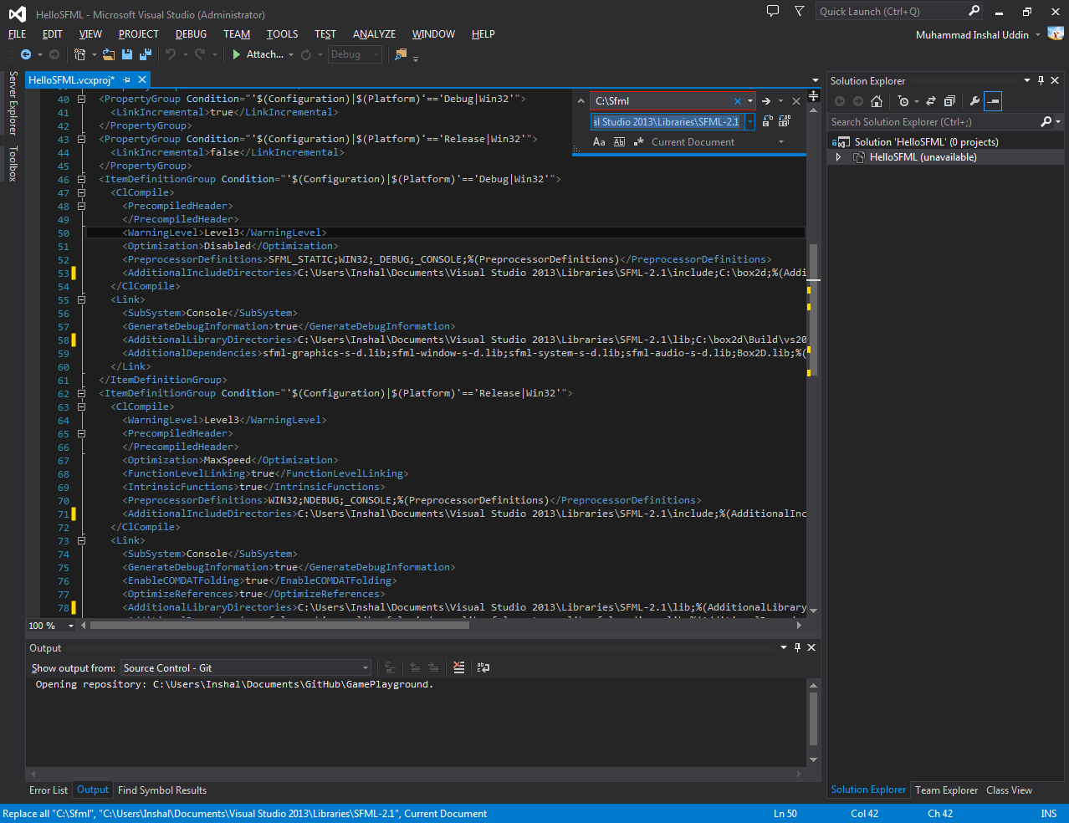Copy the directory and paste it in the other field in the replacement box and press Alt + A.

If you squint, you can see that it has done what we wanted. You would want to do the same with Box2D.

*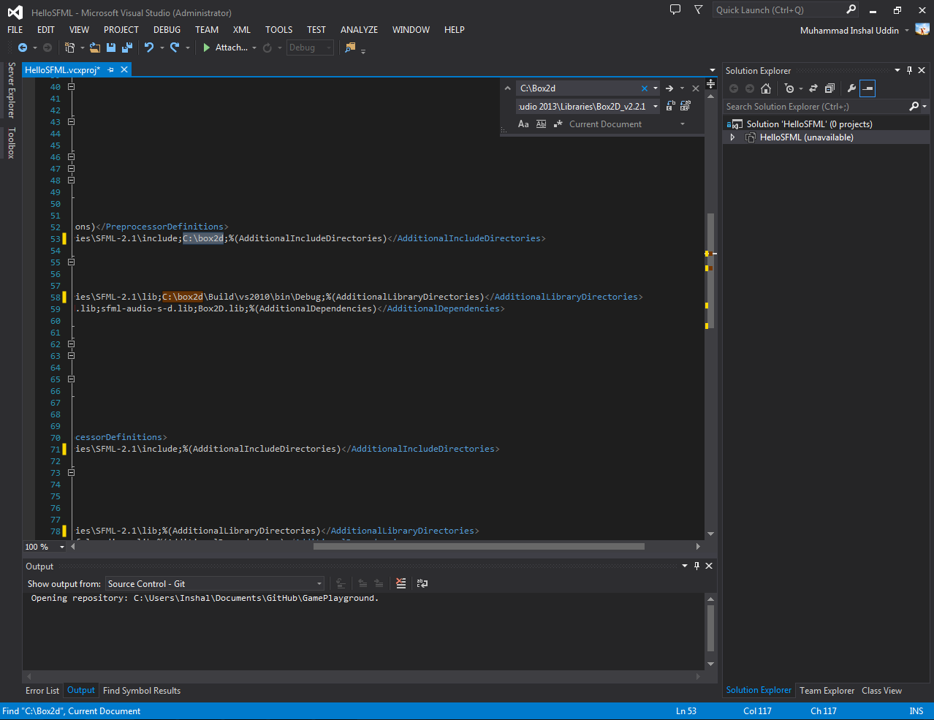A side note: There should only be* ***4 replacements for SFML*** *and* ***2 for Box2D****. If the numbers don’t match then you should probably make sure you typed “C:\SFML” in the search field rather than just “SFML”.*

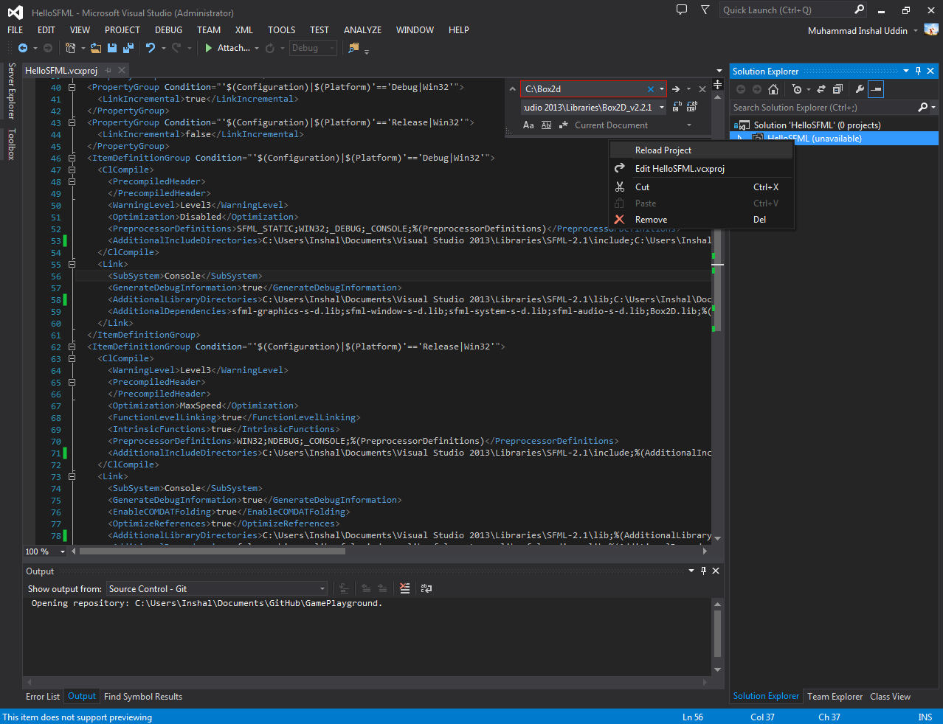Boy, that was a lot of work! Time to wrap up. Press Ctrl + S to save your meddling, and then reload the project. Click Yes when the pop up appears.

Now to test whether your changes are working correctly or not. Rebuild the project.

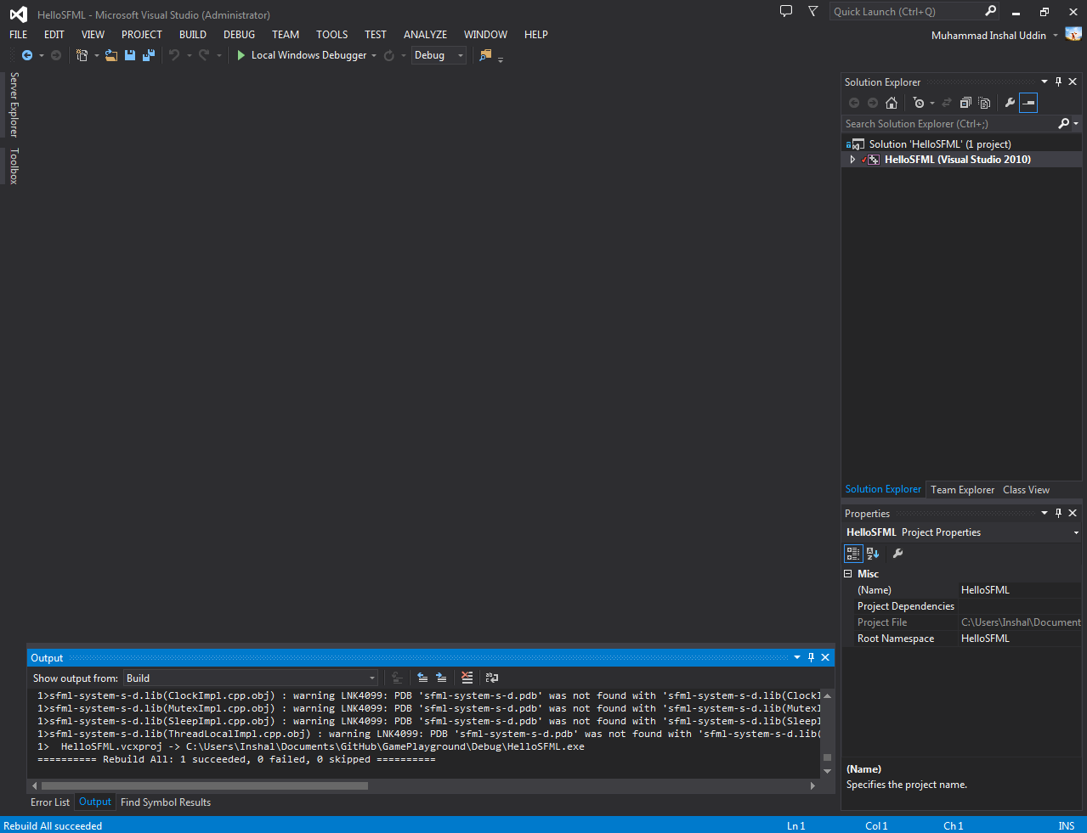You can see that it builds properly now. Now you may begin testing and playing around with the frameworks as you please.

This guide will end it’s usefulness in 3… 2… 1… This guide is now useless.